NAME: **STANLEY NGUGI CHEGE** REG NUMBER: **SCT212-0065/2017**

## ASSIGNMENT 2: FINITE AUTOMATA

**The figure below shows the state diagram of a finite automaton M1. Give the formal description of this automaton.** (5 Marks)   
**Provide a conclusion on the language accepted by this machine**

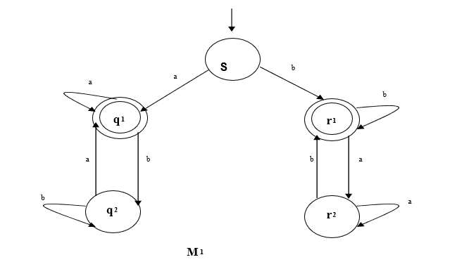

|  |  |  |
| --- | --- | --- |
|  | **Input Alphabet** | |
| **States** | a | b |
| **S** | q1 | r1 |
| **q1** | q1 | q2 |
| **q2** | q1 | q2 |
| **r1** | r2 | r1 |
| **r2** | r2 | r1 |

Q = {S, q1, q2, r1, r2}

∑= {a, b}

δ = Transition Symbol

q0= {S}

F = {q1, r1}

|  |  |
| --- | --- |
| Possible path | Pattern |
| S--*b*-->r1 | *b* |
| S--*b*-->r1--*b*-->r1 | *bb* |
| S--*b*-->r1--*a*-->r2--*b*-->r1 | *bab* |
| S--*b*-->r1--*a*-->r2--*a*-->r2--*b*-->r1 | *baab* |
| S--*b*-->r1 --*b*-->r1 --*a*-->r2--*b*-->r1 | *bbab* |
| S--*b*-->r1 --*b*-->r1 --*a*-->r2--*a*-->r2--*b*-->r1 | *bbaab* |
| S--*a*-->q1 | *a* |
| S--*a*-->q1--*b*-->q2--*a*-->q1 | *aba* |
| S--*a*-->q1--*a*-->q1 | *aa* |
| S--*a*-->q1--*a*-->q1--*b*-->q2 --*a*-->q1 | *aaba* |
| S--*a*-->q1--*a*-->q1--*b*-->q2--*b*-->q2 --*a*-->q1 | *aabba* |

**Conclusion**

The machine accepts a language that starts with an “a” and ends with an “a” or a language that starts with a “b” and ends with a “b”.

## Question Seven (from Logic & Truth Tables Lesson):

The formal description of a DFA is ({q1, q2, q3, q4, q5}, (u, d),δ q3, {q3}), where δ is given by the following transition table. Give the state diagram of this machine. (8 Marks).

u

u

u

d

d

d

d

u

u

d

q1

q2

q3

q4

q5

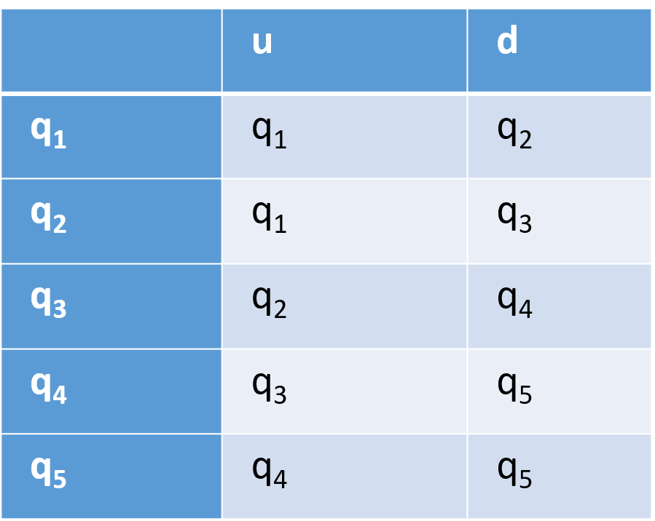

**Conclusion**

The machine accepts a language that starts with double ‘u’ and ends with double ‘d’ or starts with double ‘d’ and ends with double ‘u’.